IMAT3451 FINAL YEAR PROJECT - ETHICAL REVIEW FORM

The University requires all undergraduate final year projects to undergo an ethical review and, where human research ethical issues are identified, to ensure that these issues are addressed.

For the majority of Computing Final Year Projects, the outcome will be either ‘No ethical issues’ or ‘Minor/Major ethical issues which have been addressed’; in these cases approval can be given by the supervisor. In the unlikely event that the outcome is ‘Ethical issues that have not been addressed’, the completed form will need to be forwarded to the Faculty Research Ethics Committee.

Student Name Programme
Computer Games Programming
Connor Rowland

Project Title
Dobble

Brief description of proposed activity and its objectives:
I’m going to build a piece of software that will allow people to play a card game called Dobble together, on their computer, with their friends. It will not be tested on anybody, so there won’t be any ethical issues.

Ethical Issues Identified: How these will be addressed:
The software won’t be tested on anybody, so there won’t be any ethical issues.
There aren’t any ethical issues that need to be addressed.

Checklist

Has the project proposal identified any of the following research procedures?

1. Gathering information about human beings through: Interviewing, Surveying,
Questionnaires, Observation of human behaviour Yes / No
2. Using archived data in which individuals are identifiable Yes / No
3. Researching into illegal activities, activities at the margins of the law or
activities that have a risk of personal injury Yes / No
4. Supporting innovation that might impact on human behaviour
e.g. Behavioural Studies Yes / No

If ‘Yes’ to any of 1-4 above: have you considered the following?

□ Providing participants with full details of the objectives of the research
□ Providing information appropriate for those whose first language is not English
□ Voluntary participation with informed consent
□ Written description of involvement
□ Freedom to withdraw
□ Keeping appropriate records
□ Signed acknowledgement and understanding by participants
□ Consideration of relevant codes of conduct/guidelines

Ethical Review Outcome

□ 1. No ethical issues
□ 2. Minor ethical issues which have been addressed and concerns resolved
□ 3. Major ethical issues which have been addressed and concerns resolved
□ 4. Ethical issues that have not been resolved/addressed

Authorisation
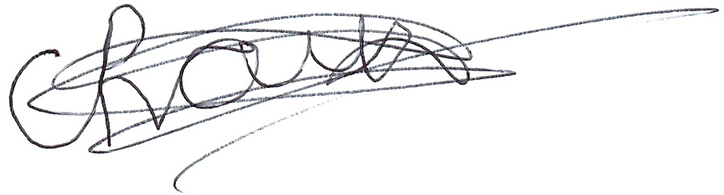
If the outcome is no. 3 or 4 above, this form should be forwarded to the Faculty Research Ethics Committee.

Signature of student ________________________________ Date 16/10/2018
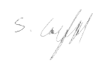

Signature of supervisor ________________________________ Date 24/10/2018

